**Individual Project 2: Chatbot**

**Chatbot name:** Saxo Chatbot

**Telegram channel:** @saxofaq_bot

**Chatbot information:** Saxo chatbot is a chatbot designed to answer common queries regarding the Saxo online broker in Singapore. The information provided in this bot can be extracted from the Frequently-asked-questions (FAQ) page on Saxo’s website and can be accessed on <https://www.home.saxo/en-sg/about-us/frequently-asked-questions> .

The questions are broadly categorized into 4 categories:

* *My account*
* *Trading*
* *Funding*
* *Platform guide*

**Flow chart of chatbot:**

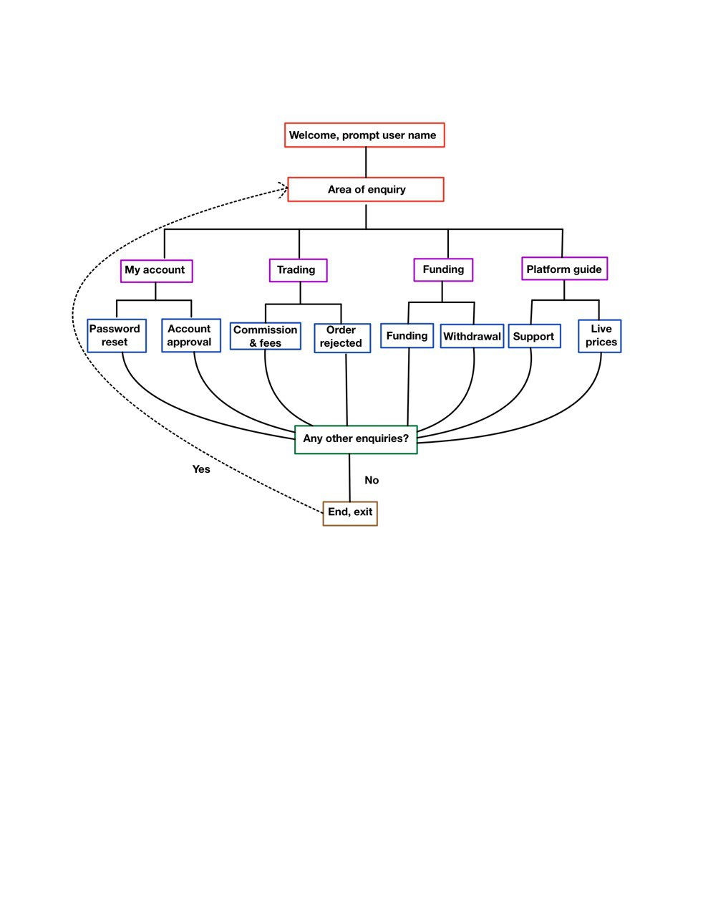

**Business applications:**

Chatbots in the customer service sectors for financial services have proven to be immensely popular and valuable. An estimation by Business Insider [1] calculated that chatbots can replace roughly 29% of common customer services enquiries and 36% of sales representatives in the United States alone. This can result in an estimated US$23 billion and US$15 billion in savings of salaries, respectively.

This tool will be especially practical and cost-saving for financial service providers like Saxo Bank, since they operate as an online investment brokerage [2] and may not have the physical staff to cater to clientele requests in all the regions that they operate in (>180 countries). By implementing a customer service chatbot that can answer common customer enquiries and issues, organisations can save time and money; being able to free up time for their customer service departments and enable them to answer to more complicated and technical requests.

**References:**

[1] <https://blogs.dxc.technology/2017/04/06/chatbots-will-pay-off-for-enterprises-but-not-so-much-for-workers/>

[2] <https://www.home.saxo/en-sg>